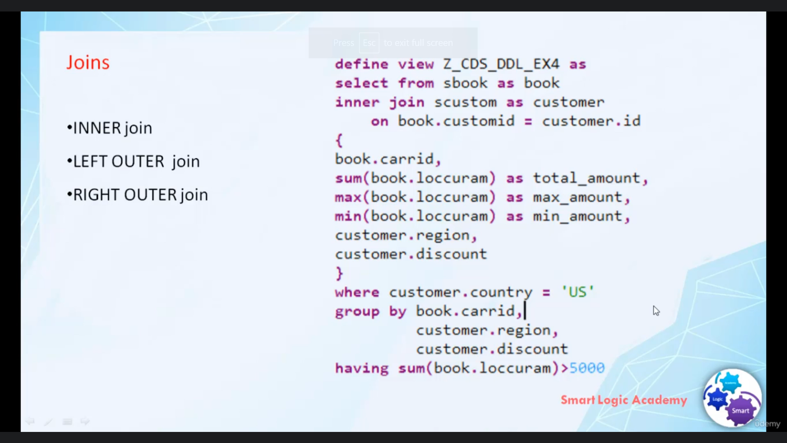

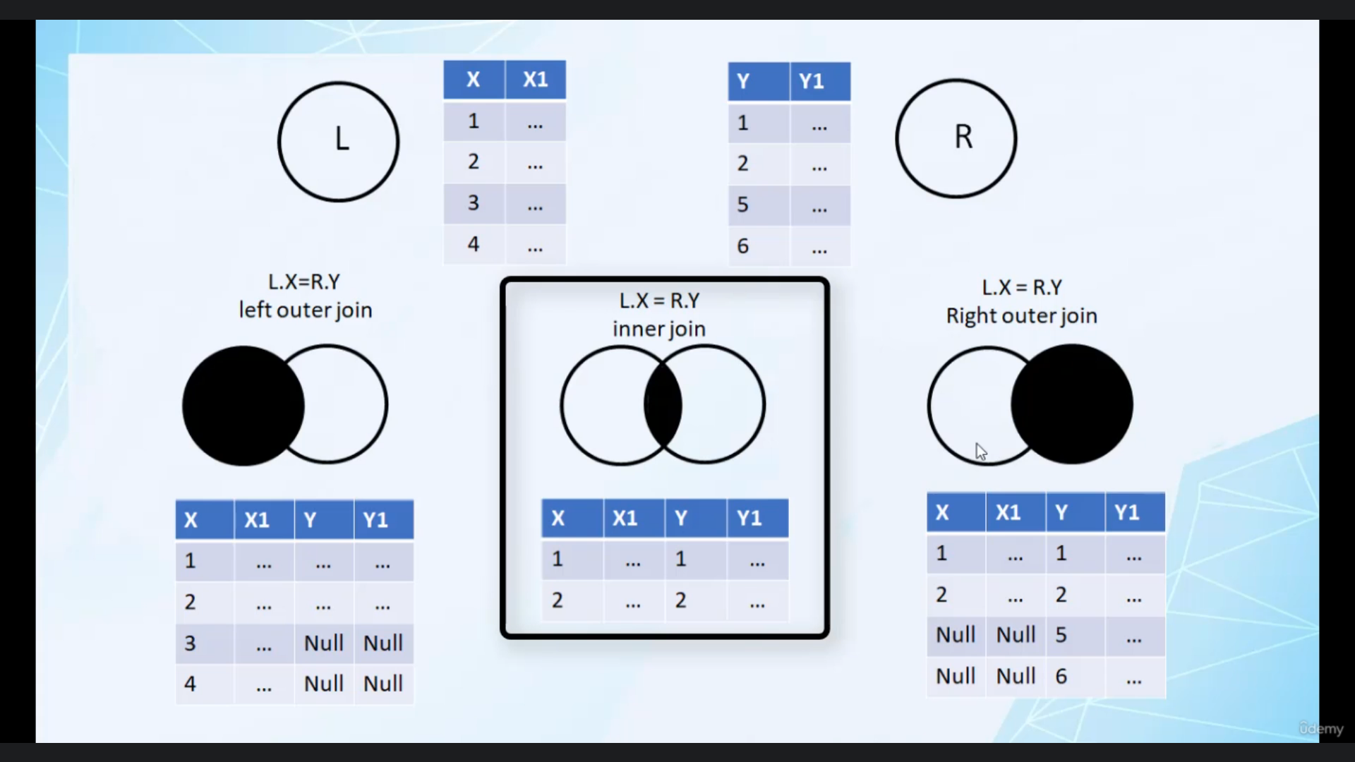 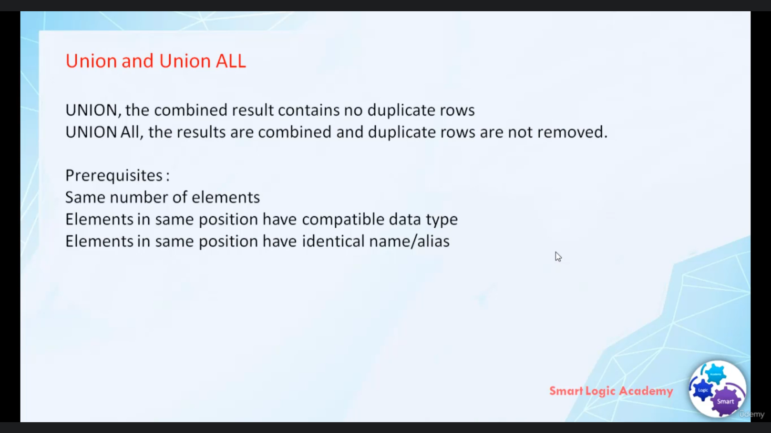

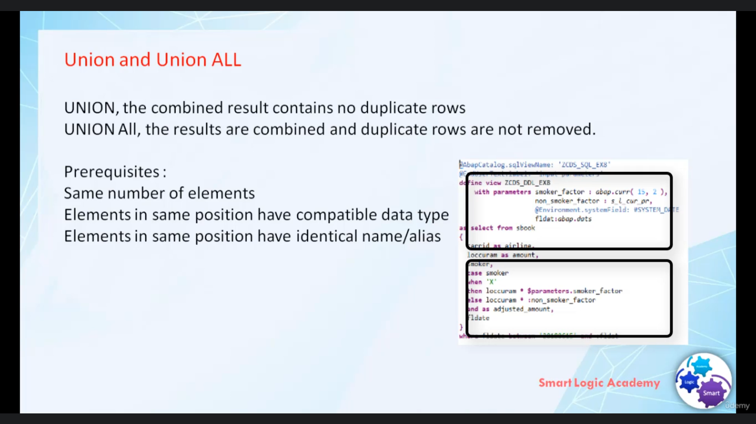

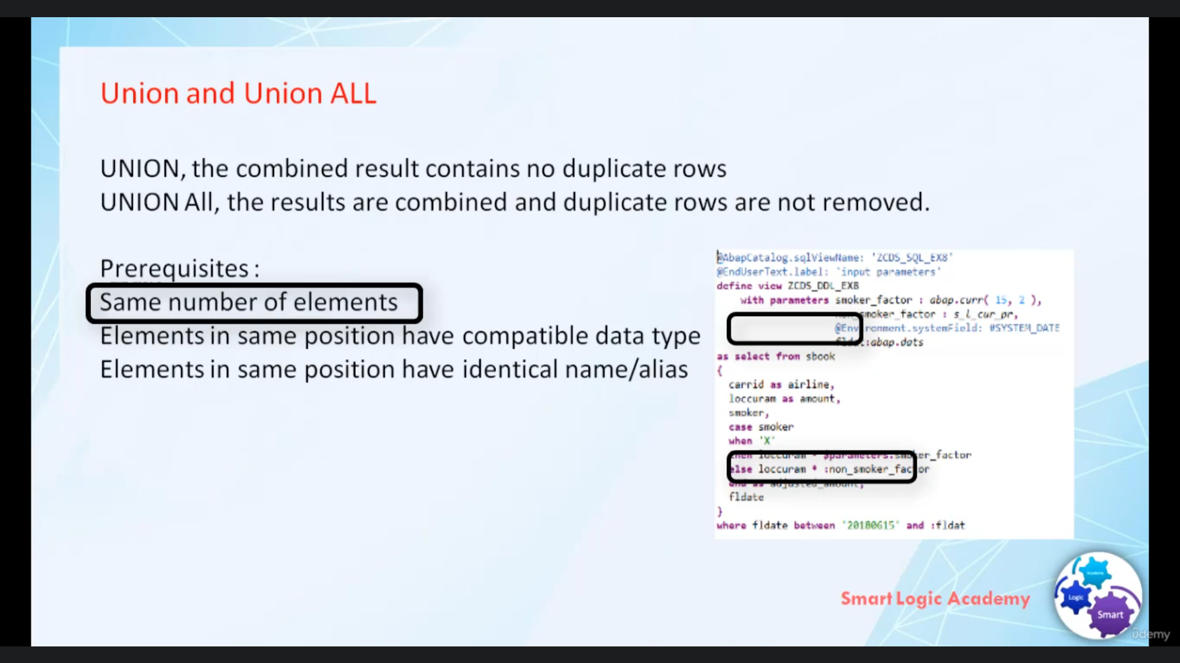

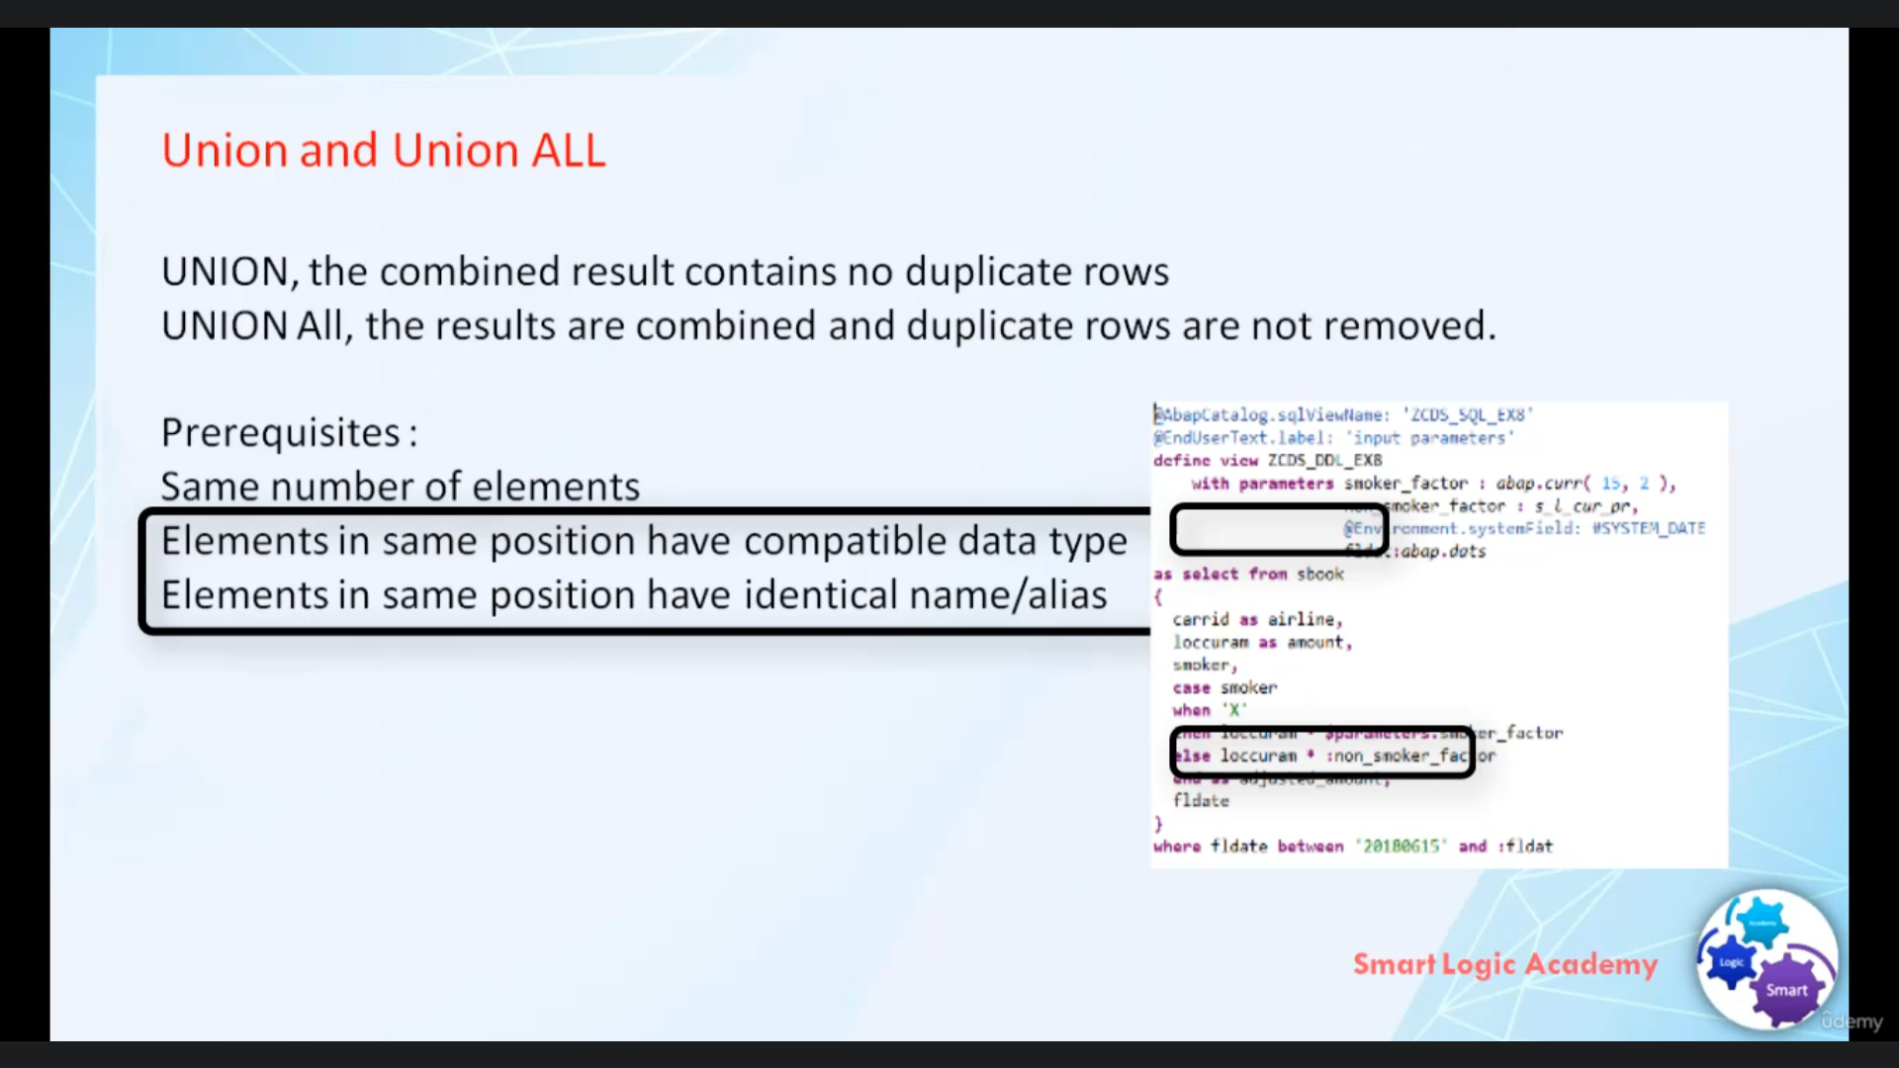

Hi, welcome back.

In this video, you will learn what different types of joints that are supported in this room, what

is union and union all and how we can use them in absolutist view.

So let's start with absolute support in our joint left outer join and trade Autogen, only these three

types of joint.

When using join in absolutist view.

The joint condition can be specified after released when using opening's relaxing tax or before full

when using Carlebach its index, it is always recommended to use the lubricants index because it supports

or completion featuring ADT Abdel-Hamid tool.

If drones are used now, as is supported on selected statements.

That means you can't use the little statement if you're using joining absolutist through.

I know you must be knowing what is in a joint left Autogen and I don't return.

Let's quickly revise and understand the functionality of the joints inner join in inner join one drop

lift table and withdraw writable are combined to accommodate the true if they fulfill the joint condition.

In left outer, join one left temple and went off writable are combined to a common dessert role if

they fulfill a joint condition like an inner join.

In addition, rule of live without marching through in writable or Cabinda Kuwaiti desert and the missing

from the right people are filled with null.

Values are left to join ensures that any dream of left table that fulfills the selection criteria appears

at least once in joint desert.

Entitled to join the rule of left and right people are a change rule of right table without matching

rule in life table or copied to the query result.

And the missing from the left table are filled with null values.

Right now, to ensure that any entry of writable that fulfill the selection criteria.

Appears at least once enjoying desert.

Now, I hope you understood the positioning of in a joint left of right now to join and now let's discuss

our union and union, all using union and union Olcay words.

You can define a view that merge the results of two or more gradings.

There is a slight difference between union and union, all in union, the combined reserve contains

no duplicate rule, while in union, all duplicate rules are not removed from reserve.

That means if the addition all is not specified or duplicate entries are removed from ResultSet and

if the addition all is specified, then all duplicate entries are not removed from ResultSet.

There are some prerequisite to use union and union, all covered in absolutist view.

There should be same number of elements in each Siliguri that you are combining.

The elements in same position must have compatible type, an identical name.

So now you literotica get over now let's create one about you dispute with Union and joins.